

FRONT END – PART 2
UNDERSTANDING DOM

(Count Clicks)

Let's make a counter using JavaScript. But it's a bit different; it increases only when you click on a box.
So create a big box in the center of the web page and add a counter below it.
When you click on the box the counter should increases by one.
The image below shows how the web page would look like -

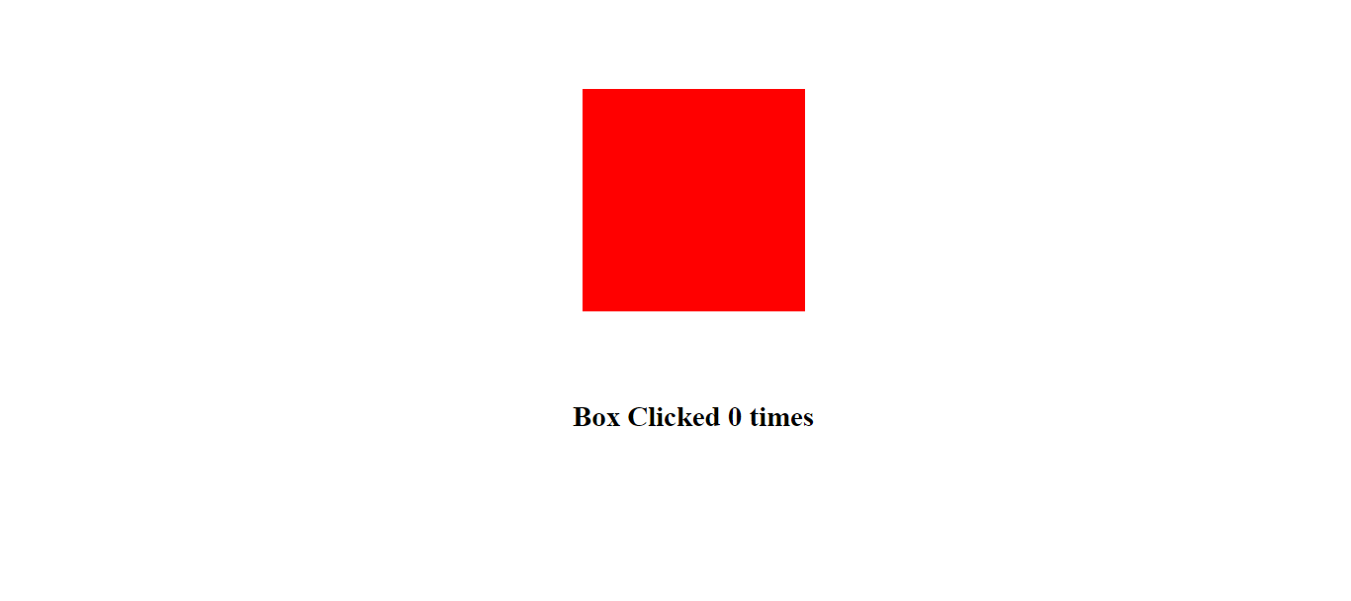

After 5 clicks on the box, the counter should show 5 as shown in image below -





